Buğra ATEŞ

Bubble Sort
Heap Sort
Radix Sort

Explanations and codes.

Case 1: O(n²) average complexity (Bubble Sort)
First pass:
(5,9,3,4,6) --> 5 is not greater than 9
(5,9,3,4,6) --> 9 > 3, swaps.
(5,3,9,4,6) --> 9 > 4, swaps.
(5,3,4,9,6) --> 9 > 6, swaps.
(5,3,4,6,9)
Second pass:
(5,3,4,6,9) --> 5 > 3, swaps.
(3,5,4,6,9) --> 5 > 4, swaps.
(3,4,5,6,9) --> 5 is not greater than 6
(3,4,5,6,9) --> 6 is not greater than 9 --> (3,4,5,6,9)

Third pass:
(3,4,5,6,9) --> 3 is not greater than 4
(3,4,5,6,9) --> 4 is not greater than 5
(3,4,5,6,9) --> 5 is not greater than 6
(3,4,5,6,9) --> 6 is not greater than 9
(3,4,5,6,9)
The remaining loops are same with third pass. Array is already sorted.

Bubble Sort Visulation
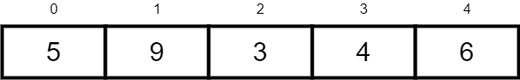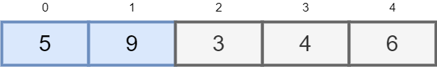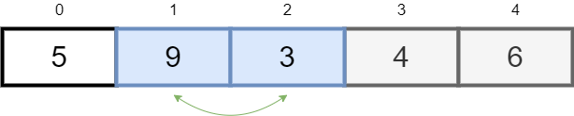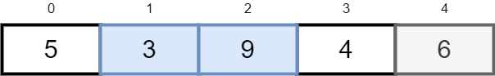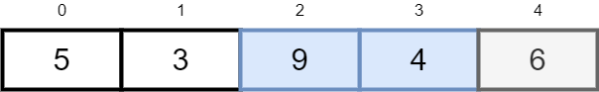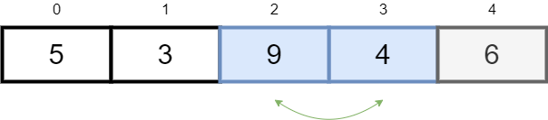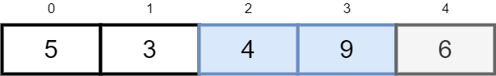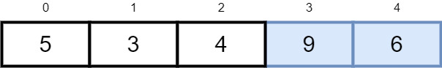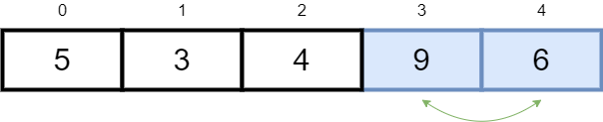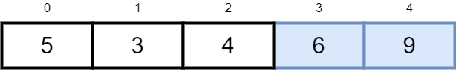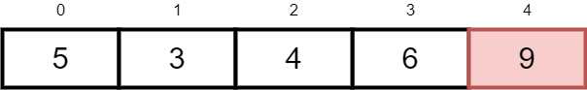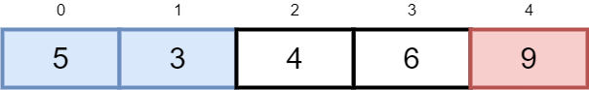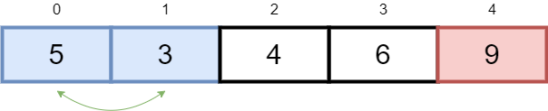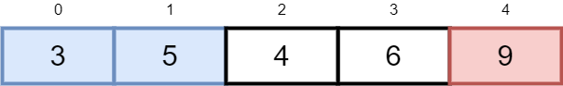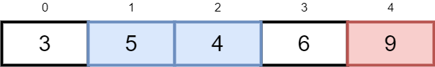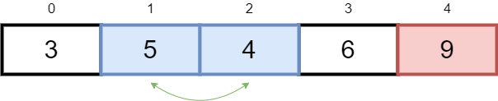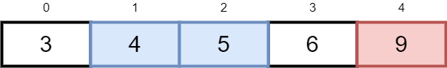
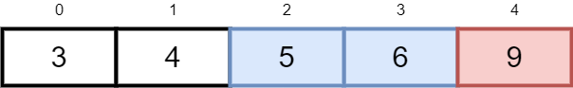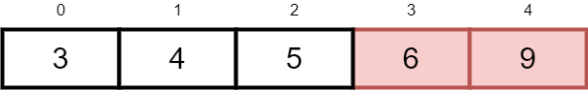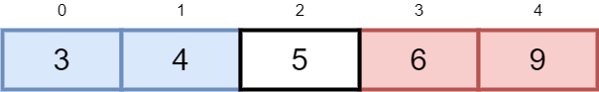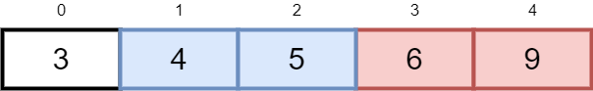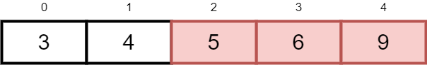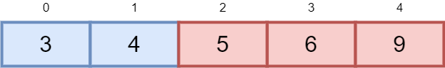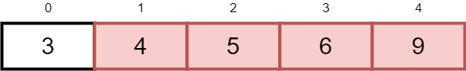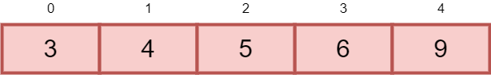

Bubble Sort Code

// Buğra ATEŞ B1705.090046
// Bubble Sort

#include <stdio.h>

void swapNumberPointers(int *firstNumPointer, int *secondNumPointer)
{
int temporaryNumPointer = *firstNumPointer;
*firstNumPointer = *secondNumPointer;
*secondNumPointer = temporaryNumPointer;
}
void bubbleSort(int numberArray[], int arraySize)
{
int i;
int j;
for (i = 0; i < arraySize-1; i++) { n
for (j = 0; j < arraySize-i-1; j++) { n^2
if (numberArray[j] > numberArray[j+1]) {
swapNumberPointers(&numberArray[j], &numberArray[j+1]);
printf("\n Pointers of numbers changed : %p <=> %p",&numberArray[j], &numberArray[j+1]);
}
}
}
}
void printArray(int numberArray[], int arraySize)
{
int i;
for (i=0; i < arraySize; i++) {
printf("%d ", numberArray[i]);
}
}
void printNumberPointers(int numberArray[], int arraySize) {
int i;
for (i=0; i < arraySize; i++) {
printf("\n %d. Index | Number : %d | Pointer = %p ",i,numberArray[i], &numberArray[i]);
} }
int main() {
int numberArray[] = {5,9,3,4,6};
int arraySize = sizeof(numberArray)/sizeof(numberArray[0]);
printNumberPointers(numberArray,arraySize);
printf("\n\n Array before (bubble) sort : ");
printArray(numberArray, arraySize);
printf("\n");
bubbleSort(numberArray, arraySize);
printf("\n\n Array after (bubble) sort : ");
printArray(numberArray, arraySize);
printf("\n");
return 0;
}
Average time complexity of bubble sort is O(n²).

Case 2: O(n*log n) average complexity (Heap Sort)

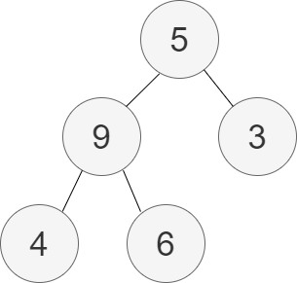

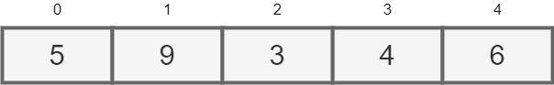

Array {5,9,3,4,6} created as a tree.
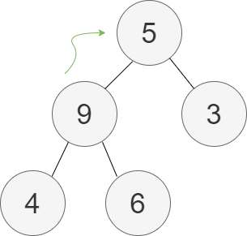

Heapify starts. We do max heap. So largest number has to be root.
Heap sort algorithm firstly tries to put the biggest number on root.

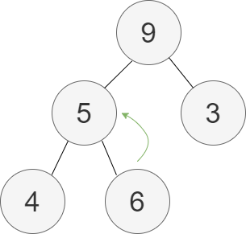

9 and 5 swapped. Now 5-6 will be swapped.

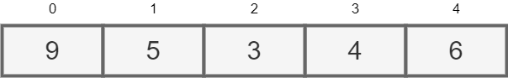

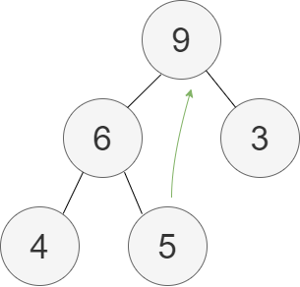

5 and 6 swapped. First and last node 5-9 will be swapped.
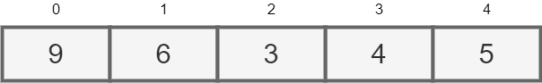

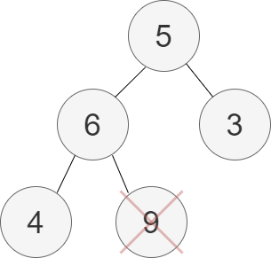

5 and 9 swapped. 9 became last node. Now 9 will be deleted.
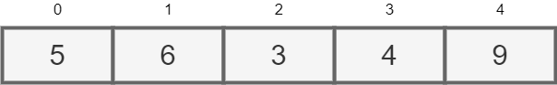

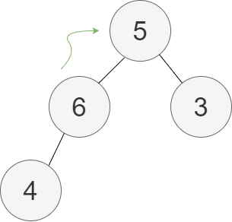

Last node (9) deleted and saved on array. Now 6-5 will be swapped.
Algorithm tries to make root the biggest one again.
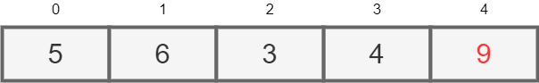

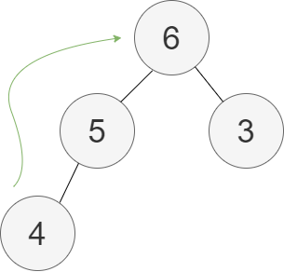

5 and 6 swapped. First and last node 4-6 will be swapped.
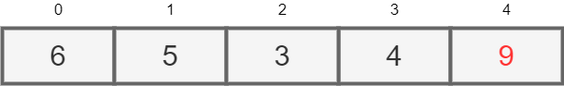

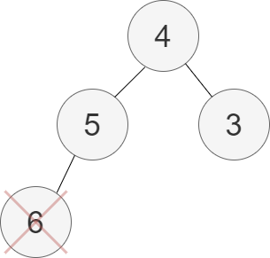

4 and 6 swapped. 6 became last node. Now 6 will be deleted.
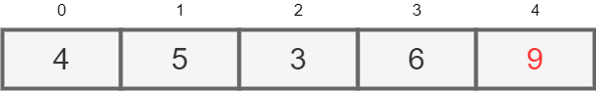

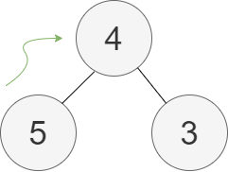

Last node (6) deleted and saved on array. Now 4-5 will be swapped.
Root will be the biggest number again.

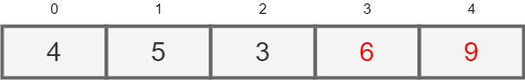

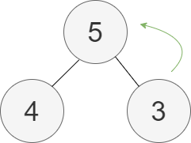

4 and 5 swapped. First and last node 3-5 will be swapped.
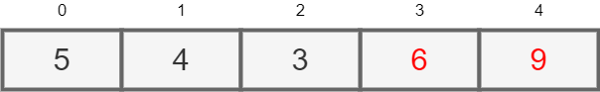

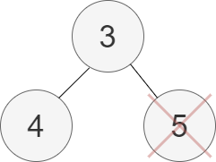

3 and 5 swapped. 5 became last node. Now 5 will be deleted.

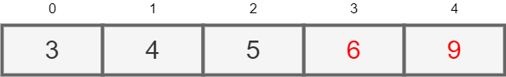

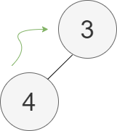

Last node (5) deleted and saved on array. Now 3-4 will be swapped.
Root will be the biggest number again.
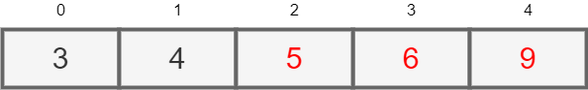

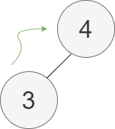

3 and 4 swapped. First and last node 3-4 will be swapped again.

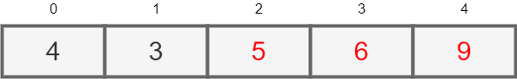

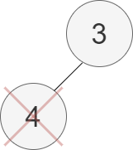

3 and 4 swapped. 4 became last node. Now 4 will be deleted.



Last node (4) deleted and saved on array.
There is only one node remains.

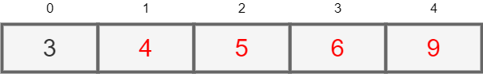

Last single node will be deleted and array will be completely sorted.
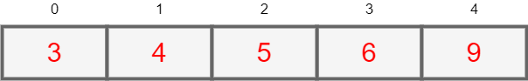

Heap Sort Code

// Buğra ATEŞ B1705.090046
// Heap Sort
#include <stdio.h>
void swapNumberPointers(int *firstNumPointer, int *secondNumPointer)
{
int temporaryNumPointer = *firstNumPointer;
*firstNumPointer = *secondNumPointer;
*secondNumPointer = temporaryNumPointer;
}
void heapify(int numberArray[], int n, int i) {
// Find largest among root, left child and right child
int largest = i;
int left = 2 * i + 1;
int right = 2 * i + 2;

if (left < n && numberArray[left] > numberArray[largest])
largest = left;

if (right < n && numberArray[right] > numberArray[largest])
largest = right;

// Swap and continue heapifying if root is not largest
if (largest != i) {
swapNumberPointers(&numberArray[i], &numberArray[largest]);
heapify(numberArray, n, largest);
}
}

// Main function to do heap sort
void heapSort(int arr[], int arraySize) {
// Build max heap
for (int i = arraySize / 2 - 1; i >= 0; i--)
heapify(arr, arraySize, i);

// Heap sort
for (int i = arraySize - 1; i >= 0; i--) {
swapNumberPointers(&arr[0], &arr[i]);

// Heapify root element to get highest element at root again
heapify(arr, i, 0);
}
}
void printArray(int numberArray[], int arraySize)
{
int i;

for (i=0; i < arraySize; i++)
{
printf("%d ", numberArray[i]);
}
}
int main() {

int numberArray[] = {5,9,3,4,6};
int arraySize = sizeof(numberArray)/sizeof(numberArray[0]);
printf("\n Array before (heap) sort : ");
printArray(numberArray, arraySize);
heapSort(numberArray, arraySize);
printf("\n\n Array after (heap) sort : ");
printArray(numberArray, arraySize);
printf("\n"); }
Case 3: O(n) average complexity (Radix Sort)

Radix sort is the sorting method obtained by evaluating the number digits one by one.
In this example, all the array numbers have one digit.
So, there is no ten’s or hundred’s places to check.
There are two alternate methods to use with Radix sort that are Counting and Bucket sort.
In this example we continue with Counting Sort.
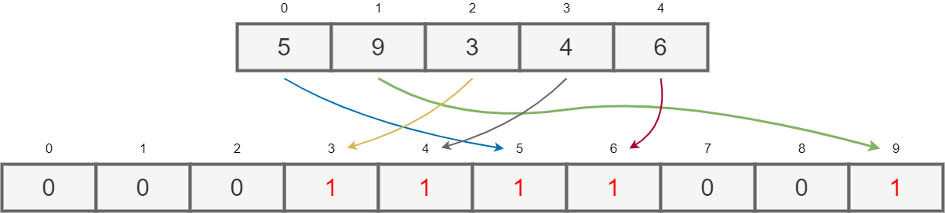

We have second array that its size is 10 (numbers).
We have numbers that they have only one digit.
According to numbers in each index in input array, we use those numbers for finding same index value.
(Index value and input array’s number value)
When we go to this index, we write 1 in inside it.

After this process, in pairs we add the numbers in each index to the next one, starting from the left.
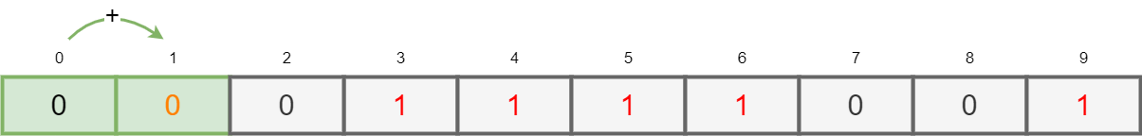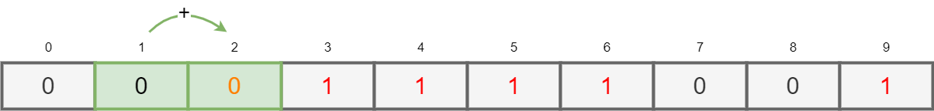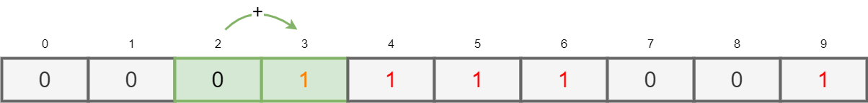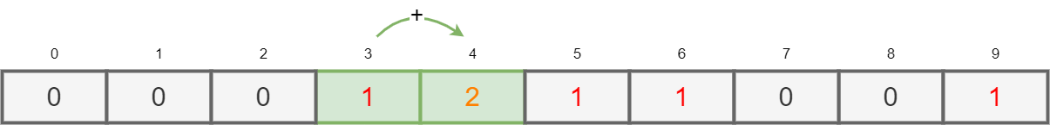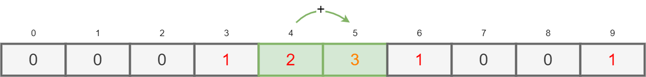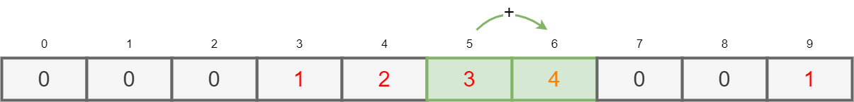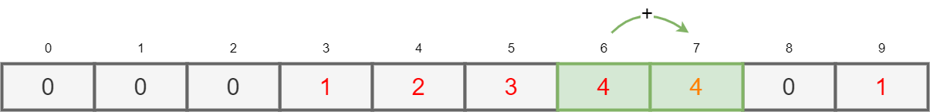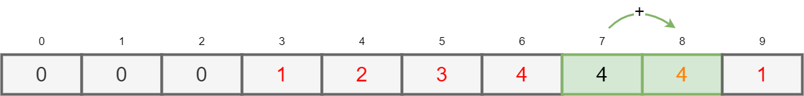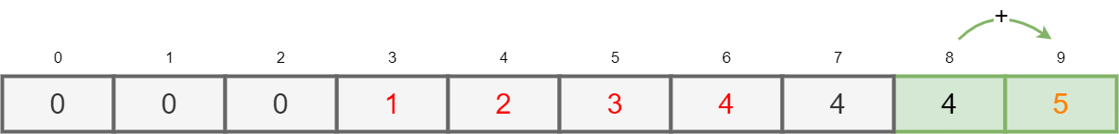

After adding process, second array seems like that.
Now we can use our two arrays to fill output array.
Algorithm starts last index of input array and checks the number.
After that, it finds the index number that same with checked number.
After index found, it subtracts 1 from number that in this index.
The number obtained after subtraction is used as index in output array.
Finally, the number we got from input array is placed
in this index of output array. It keeps running until reach to first index.
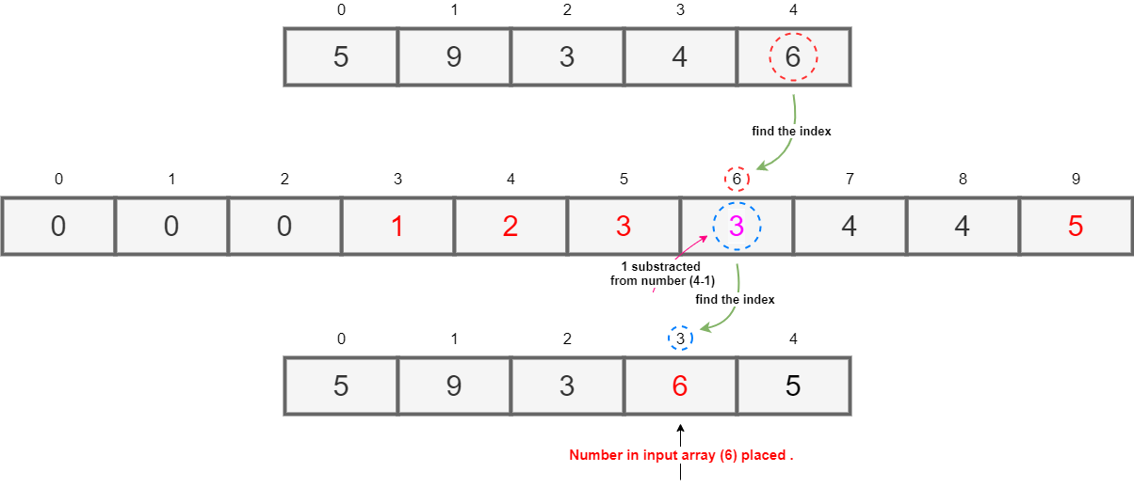

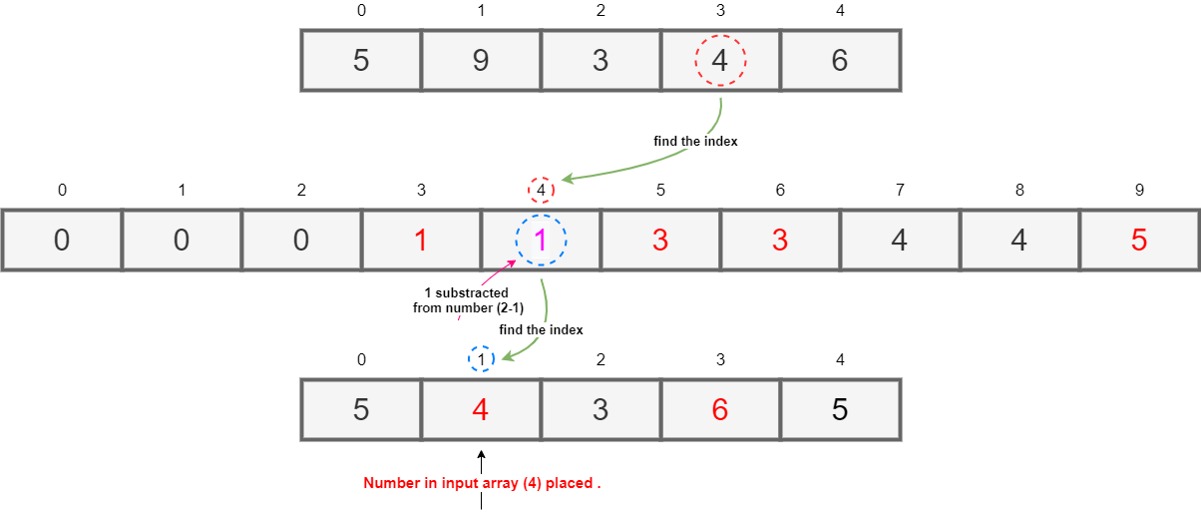
Third index of output array placed. (6)

First index of output array placed. (4)

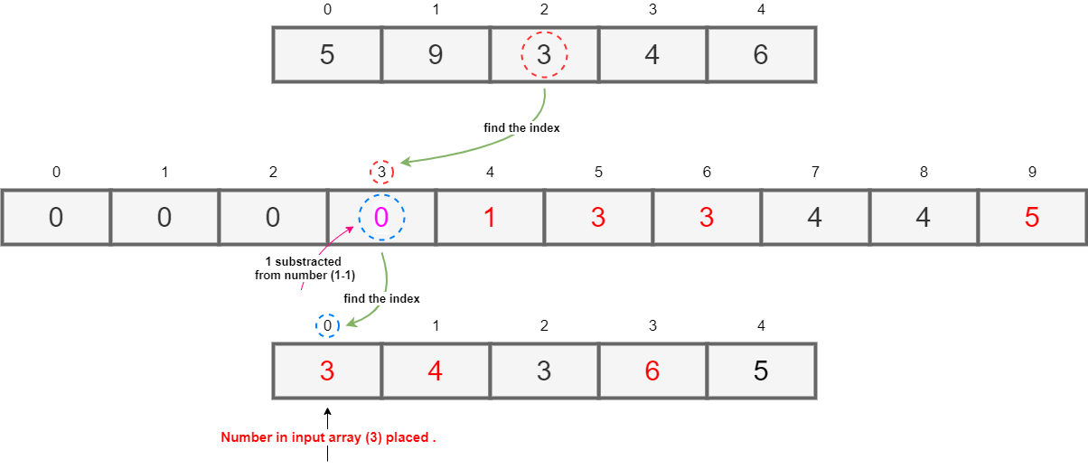

Zero index of output array placed. (3)

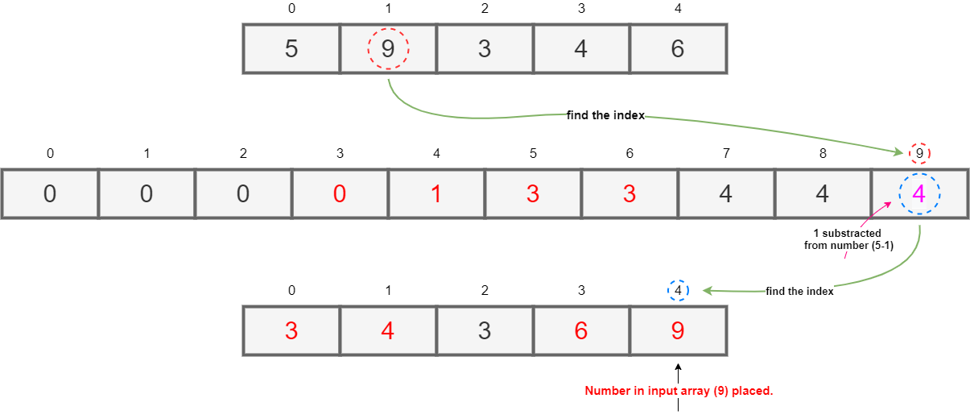

Fourth index of output array placed. (9)

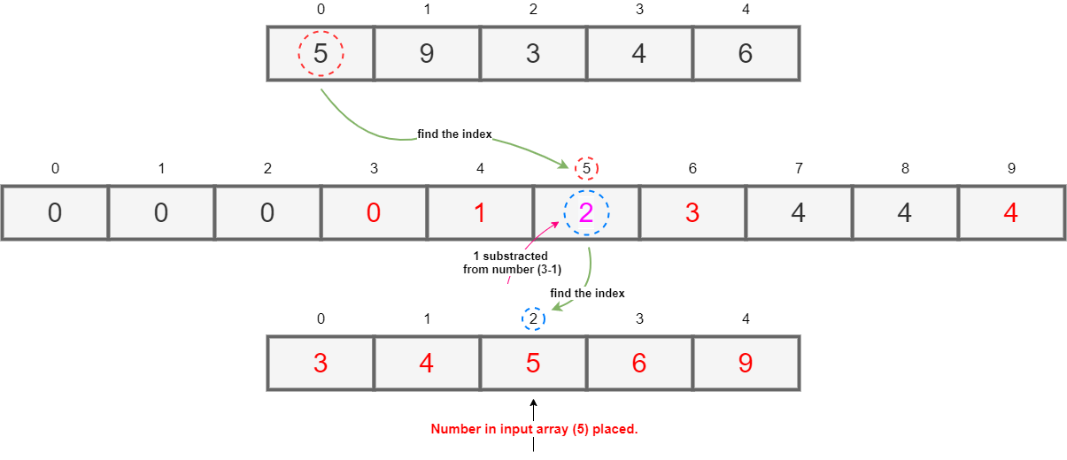

Second and final index of output array placed. (5)

All indexes of output array filled.
Numbers sorted in ascending order from left to right.

Radix Sort Code

// Buğra ATEŞ B1705.090046
// Radix Sort

#include <stdio.h>

int getMax(int arr[], int n) {
int mx = arr[0];

for (int i = 1; i < n; i++) if (arr[i] > mx) {
mx = arr[i];
}
return mx; }
void countSort(int numberArray[], int arraySize, int exp) {
int output[arraySize]; // output array
int i, count[10] = {0};

for (i = 0; i < arraySize; i++) {
count[ (numberArray[i]/exp)%10 ]++;
}

for (i = 1; i < 10; i++) {
count[i] += count[i - 1];
}

for (i = arraySize - 1; i >= 0; i--) {
output[count[ (numberArray[i]/exp)%10 ] - 1] = numberArray[i];
count[ (numberArray[i]/exp)%10 ]--;
}

for (i = 0; i < arraySize; i++) {
numberArray[i] = output[i];
}
}
void radixsort(int numberArray[], int arraySize) {
int m = getMax(numberArray, arraySize);

for (int exp = 1; m/exp > 0; exp *= 10)
{
countSort(numberArray, arraySize, exp); } }

void printArray(int numberArray[], int arraySize) {
int i;
for (i=0; i < arraySize; i++) {
printf("%d ", numberArray[i]);
}
}

int main()
{
int numberArray[] = {5,9,3,4,6};
int arraySize = sizeof(numberArray)/sizeof(numberArray[0]);

printf("\n Array before (radix) sort : ");
printArray(numberArray, arraySize);

radixsort(numberArray, arraySize);

printf("\n\n Array after (radix) sort : ");
printArray(numberArray, arraySize);
printf("\n");

return 0; }

(10 point) Here n is 5, if we have 1000 elements, what changes?

When we would have 1000 elements in the array, radix sort would not be that effective, it would use explicit spaces. Time complexity is O(n), so for example we have 5 loops in our code and there are 1000 elements to sort. 5*n or 5n+1 or 5+5 these numbers do not affect the complexity. They affect run time. So, our complexity chart stays same but time of creating this chart, increases with same linear time.
Number of elements (1000) that are inputs or changes on n (5) affects running time for radix sort.
Differences of “n” can make them worst case.

Buğra ATEŞ
B1705.090046

